DEPARTMENT OF COMPUTER TECHNOLOGY- UG KONGU ENGINEERING COLLEGE
(Autonomous)
PERUNDURAI ERODE – 638060
MARCH 2026

BONAFIDE CERTIFICATE

This is to certify that the project report titled AUTOWEAVE ENTERPRISE RESOURCE MANAGEMENT SYSTEM is the approved record of work done by ENIGA P (REG. NO: R23BCR015), GOPIKA S (REG. NO: 23BCR017), SAMEEKA N (REG. NO:23BCR046) in partial fulfillment for the award of Degree of Bachelor of Science in Computer Systems and Design of Anna University Chennai during the year 2025-2026.

SUPERVISOR HEAD OF THE DEPARTMENT
(Signature with seal)

Date:
Submitted for the end semester viva- voce examination held on

INTERNAL EXAMINER EXTERNAL EXAMINER

DEPARTMENT OF COMPUTER TECHNOLOGY- UG KONGU ENGINEERING COLLEGE
(Autonomous)
PERUNDURAI ERODE – 638060
MARCH 2026

DECLARATION

We affirm that the project titled AUTOWEAVE ENTERPRISE RESOURCE MANAGEMENT SYSTEM being submitted in partial fulfillment for the award of B.Sc. Degree in Computer Systems and Design is the original work carried out by us. It has not formed the part of any other project submitted for award of any degree, either in this or any other University.

ENIGA P (REG. NO:23BCR015)
GOPIKA S (REG. NO:23BCR017)
SAMEEKA N (REG. NO:23BCR046)

Date:

I certify that the declaration made above by the candidates is true to the best of my knowledge.
Date: Name & Signature of the Supervisor

ABSTRACT

The AutoLoom Textile Stock Management System is a web-based, user-friendly system developed for the record-keeping and monitoring of the everyday activities of textile weaving units and small-scale industries in the loom sector. Usually, textile shops depend on maintaining records through manual registers regarding the meterage of raw materials, the work status of employees, financial transactions, etc., which often result in errors and delays. It allows for the centralized management of raw materials, employee details, and salary calculations, along with providing daily production reports through automated means.
The salient feature of this system is cloth meter assessment, wherein the customer provides raw material, in the form of yarn or cloth length, to the shop. The processed output in usable meters is calculated and recorded in the system for correct tracking and exchange with the customer for mismanagement of the material. Complete employee profiles comprising attendance, assigned tasks, and automated computation of salary according to the work type, completed output, or on a monthly basis. This will bring transparency, lessen manual workload, and provide more accuracy in payroll.
The platform provides an interactive dashboard that offers real-time insights on the functioning of the shop. It visualizes daily, weekly, and monthly performances through charts and summary statistics on overall raw material received, meters processed, employees' productivity, and salary expenses. These analytics enable a shop owner to make informed decisions, identify production patterns, and further optimize the allocation of resources accordingly.
The AutoLoom Textile Stock Management Website increases efficiency in operations through the full automation of stock management, handling by employees, and performance reporting. The system is scalable, user-friendly, and adaptable to various types of loom-based shops, making it a reliable digital solution for modern textile workflow management.

ACKNOWLEDGEMENT

We express our sincere thanks to our beloved Correspondent Thiru.A.K.ILANGO B.Com., M.B.A., LLB., and other philanthropic trust members of Kongu Vellalar Institute of Technology Trust for having provided with necessary resources to complete this project.
We are always grateful to our beloved visionary Principal Dr.R.PARAMESHWARAN M.E., Ph.D., and thank him for his motivation and moral support.
We express our deep sense of gratitude and profound thanks to Dr.S.KALAISELVI MCA., ME., Ph.D., Head of the Department, Computer Technology- UG for her invaluable commitment and guidance for this project.
We are in immense pleasure to express our hearty thanks to our beloved Coordinator Dr.K.SARASWATI Msc.,M.phil.,Ph.D., and our project guide Ms.M.HEMALATHA MCA for providing valuable guidance and constant support throughout the course of our project. We also thank the teaching, non- teaching staff members, fellow students and our parents who stood with us to complete our project successfully.

TABLE OF CONTENTS

CHAPTER No. | TITLE | PAGE No.
 | ABSTRACT | iii
 | LIST OF TABLE | vi
 | LIST OF FIGURES | vii
 | LIST OF ABBREVIATIONS | viii
 | ACCEPTANCE LETTER | ix
1 | INTRODUCTION | x
1.1 | PROBLEM DEFINITION | x
1.2 | OBJECTIVE OF THE PROJECT | xi

LIST OF TABLES

TABLE No TABLE NAME PAGE NO
20
    - USER TABLE
20
    - ADMIN TABLE
21
    - PRODUCT TABLE
    - CART TABLE 21
    - ORDER TABLE 22
    - PRESCRIPTION TABLE 22

 | LIST OF FIGURES
FIGURE No. | FIGURE NAME | PAGE No.
4.1.1 | USECASE | 20
4.1.2 | SYSTEM FLOW | 20
4.1.3 | ER DIAGRAM | 21

LIST OF ABBREVIATIONS

ABBREVIATION | EXPANSION
HTML | Hypertext Markup Language
JS | JavaScript
MERN | Mongo DB  Express  React  Node JS
CSS | Cascading Style Sheet

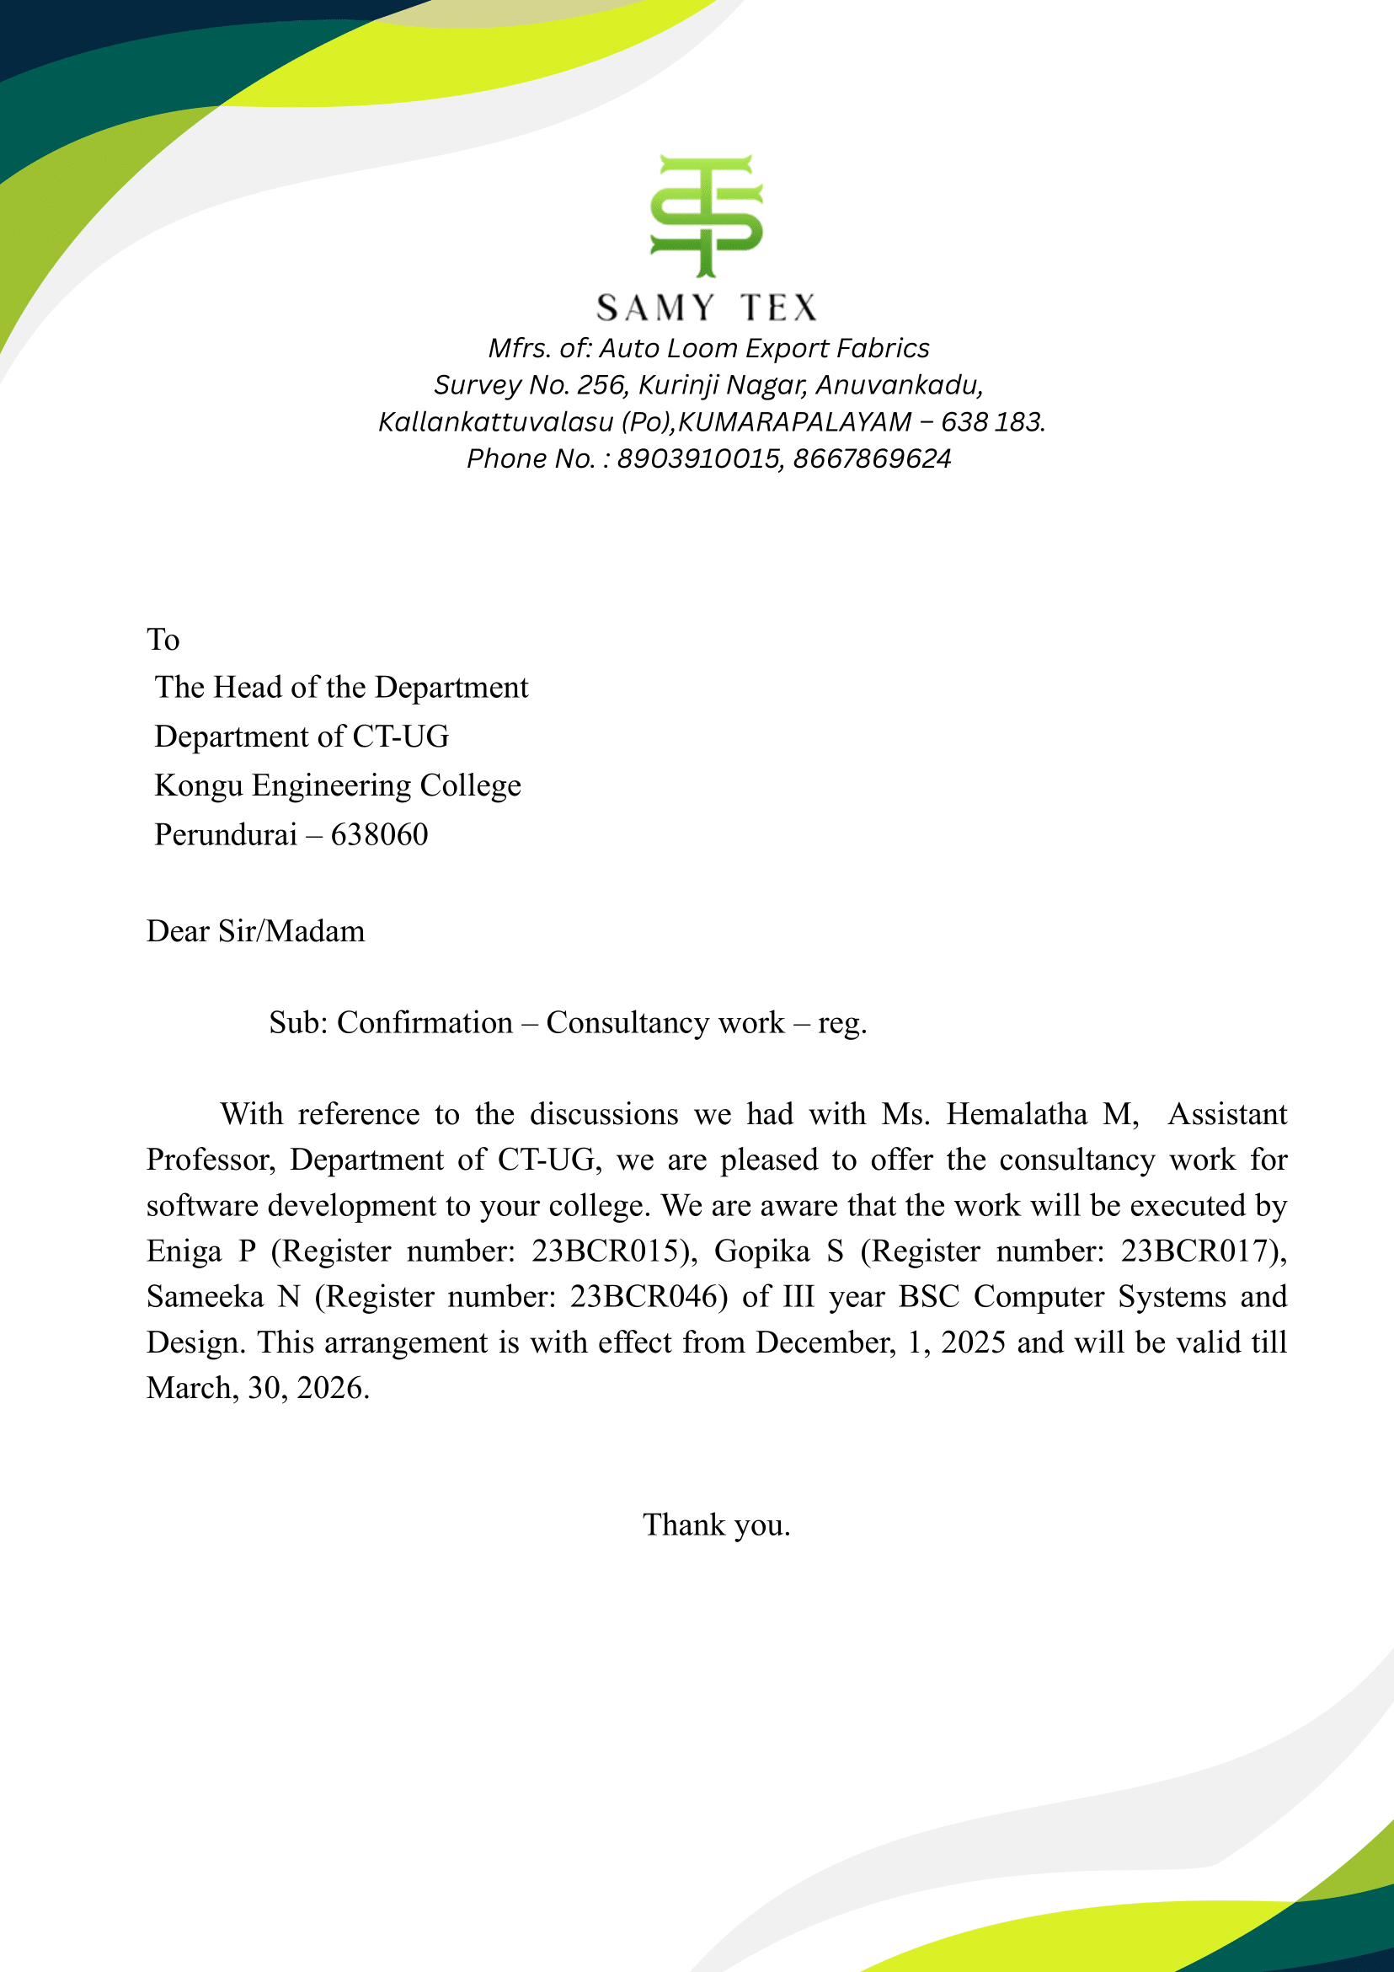
ACCEPTANCE LETTER

CHAPTER 1

INTRODUCTION

1.1 PROBLEM DEFINITION

The textile manufacturing industry, particularly the auto-loom sector, faces significant operational challenges due to fragmented and manual management systems. Small to medium-sized auto-loom businesses struggle with tracking machine performance, worker attendance, order fulfillment, and production metrics in real-time. Traditional manual record-keeping methods are error-prone, time-consuming, and fail to provide the visibility necessary for informed decision-making. Business owners lack centralized access to critical operational data such as machine efficiency, defect rates, worker productivity, and order status, leading to suboptimal resource utilization, quality control issues, delayed responses to production problems, and missed delivery deadlines that result in customer dissatisfaction.

The absence of integrated digital solutions creates multiple operational bottlenecks across the production workflow. Machine operators have no centralized system to log shift details, track daily meter production per loom, or monitor downtime and defect rates, making it impossible to identify underperforming machines or maintain consistent quality standards. Worker management suffers from manual attendance tracking and payroll processing, which consumes substantial administrative effort and lacks integration with modern payment systems, resulting in delayed salary disbursements. Order management is equally problematic, with poor visibility into production progress and no systematic way to prioritize orders, allocate resources effectively, or provide customers with accurate delivery timelines.

AutoWeave ERP addresses these comprehensive challenges by providing an integrated, web-based enterprise resource planning system specifically designed for auto-loom manufacturing businesses. The system consolidates machine management, worker tracking, order fulfillment,
production monitoring, and payroll processing into a unified platform with real-time data synchronization using MongoDB backend storage. By automating routine tasks, providing comprehensive dashboards with key performance indicators, enabling detailed reporting capabilities in multiple formats (PDF and Excel), and integrating modern payment solutions like Razorpay for digital salary disbursement, AutoWeave ERP empowers business owners to gain complete operational visibility, make data-driven decisions, and significantly improve efficiency while reducing administrative overhead and operational costs.

1.2. OBJECTIVE OF THE PROJECT

The primary objective of the AutoWeave ERP project is to develop a comprehensive, web-based enterprise resource planning system tailored specifically for auto-loom manufacturing businesses. The system aims to digitize and streamline all critical operational processes, replacing fragmented manual systems with an integrated platform that provides real-time visibility into production, workforce management, order fulfillment, and financial operations. By centralizing data management and automating routine administrative tasks, the project seeks to empower business owners and managers with actionable insights that enable data-driven decision-making, improve operational efficiency, and enhance overall business performance in the competitive textile manufacturing sector.

A key objective is to implement robust machine and production management capabilities that enable comprehensive tracking of loom performance and output. The system aims to provide operators and supervisors with intuitive interfaces to log shift details, record daily meter production for each loom, track machine downtime, and document defect rates in real-time. By automatically calculating efficiency metrics, identifying underperforming machines, and correlating quality issues with specific operational patterns, the platform will enable proactive maintenance scheduling, optimize resource allocation, and maintain consistent quality standards. The production monitoring module will also support target-based tracking, allowing businesses to measure actual performance against planned production goals and take corrective actions promptly.

Another critical objective is to revolutionize worker management and payroll processing through digital automation and integration with modern payment systems. The system aims to eliminate manual attendance tracking by providing a centralized platform where shift assignments, attendance records, and working hours are automatically captured and stored. By implementing automated salary calculations based on shift attendance (at Rs. 750 per shift), maintaining comprehensive payment histories, and integrating Razorpay for digital salary disbursement, the project seeks to reduce administrative burden, minimize payroll errors, ensure timely payments, and improve worker satisfaction. The worker management module will also enable performance tracking and provide insights into workforce productivity patterns.

The project also aims to enhance order management and customer satisfaction by providing end-to-end visibility into the order fulfillment process. The system will enable businesses to efficiently capture customer orders with detailed specifications (customer name, product type, quantity in meters, and deadlines), track order status through various stages (Pending, In Production, Completed), and monitor production progress against delivery timelines. By providing real-time updates on order fulfillment status and enabling better resource planning and prioritization, the platform will help businesses meet customer commitments consistently, reduce delays, and build stronger customer relationships.

Finally, the project objectives include delivering comprehensive reporting and analytics capabilities that transform raw operational data into strategic business intelligence. The system aims to provide customizable report generation for various operational aspects including daily production summaries, machine efficiency analyses, defect rate trends, and order fulfillment status. By supporting multiple export formats (PDF for presentations and Excel for detailed analysis) and maintaining historical data for trend analysis, the platform will enable business owners to identify improvement opportunities, forecast capacity requirements, demonstrate performance to stakeholders, and make informed strategic decisions about equipment investments, workforce planning, and process optimization initiatives.

